**Major Assignment – 01 (Python – CSE3651)**

**Name : Nabin Kumar Shaw**

**Regd. No. : 2241019424**

**Section : 2241027**

**Branch : CSE**

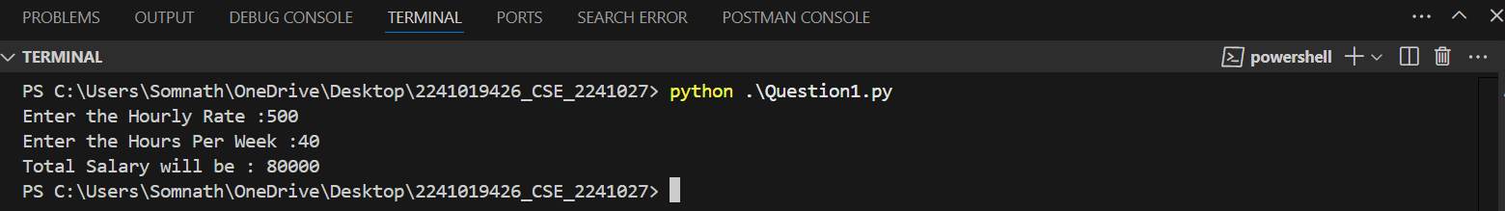Question 1.

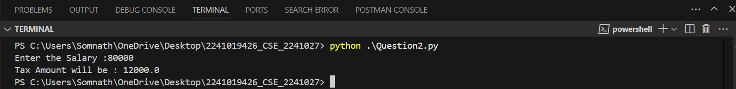Question 2.

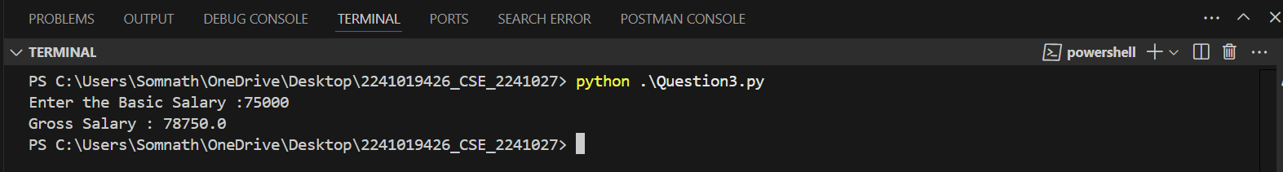Question 3.

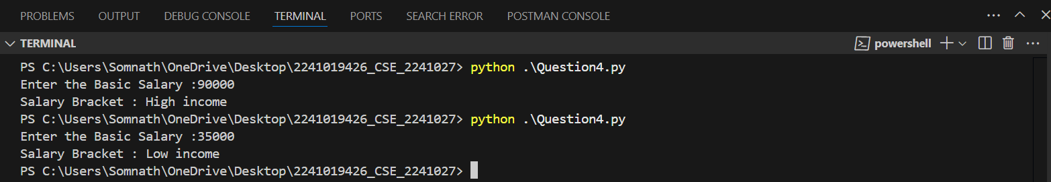Question 4.

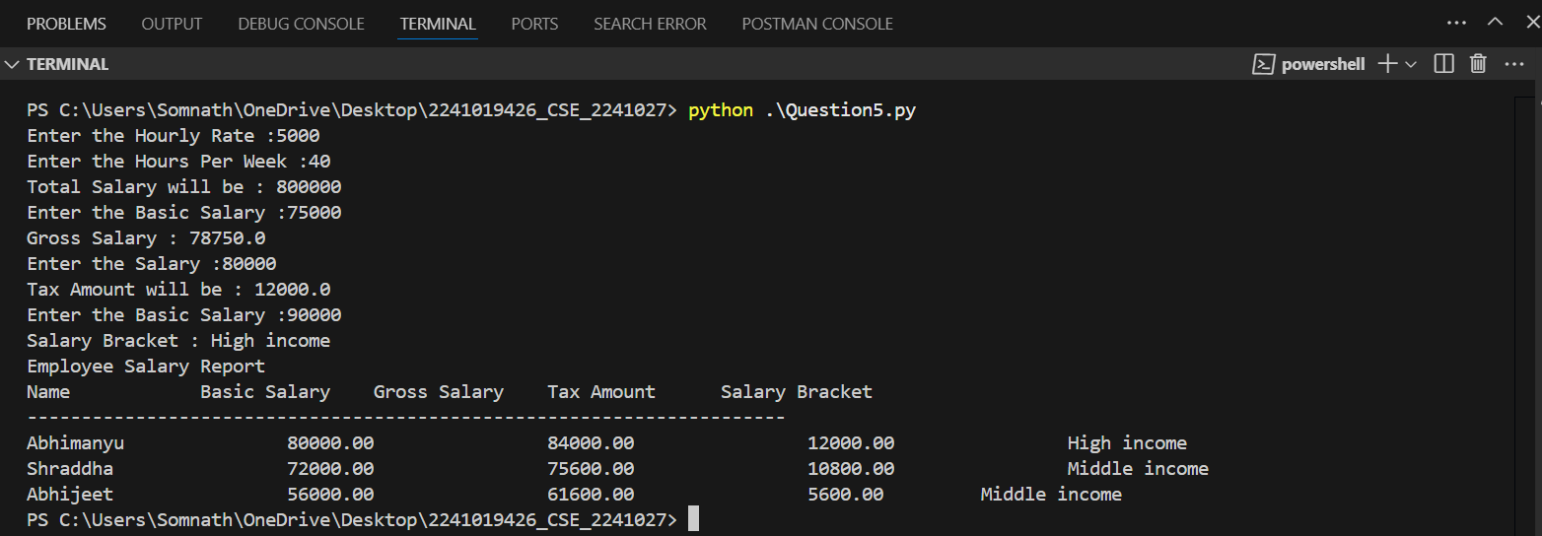Question 5.